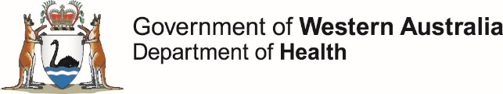

Talent release and consent form
I understand that:
- I give consent to be filmed, photographed, recorded and/or interviewed
(‘the Material’) by the Department of Health.
- I give the Department of Health the right to use the Material for the purpose of promoting public health in any way, including but not limited to:
  - broadcasting or publishing the Material
  - communicating the Material to the public
  - reproducing or creating derivative works of the Material in any way including but not limited to film, posters, brochures, audio, video and websites
  - reproducing quotes and interview text, in written, audio, video or other formats.
- the Department of Health will retain the Material and may display and re-use it at any time, in multiple occurrences, with no further consent or communication.
- I will not be paid at any time for this consent.
- the Department of Health owns the copyright and all intellectual property rights in the Material.
- I agree not to make any claim against the Department of Health or its officers, employees and agents arising out of the use of the Material.
- the interview(s), if applicable, will ◻ identify me ◻ not identify me.
- in the unfortunate event of the death of a person photographed, filmed or interviewed, the Department of Health, if informed of the death:
  - will immediately cease to use the Material in any way, if requested
  - cannot withdraw any materials, including electronic products, which are already in circulation.
Signature Date
Please print all personal details*
First name Age
Family name
Address
Phone
Email
I am the consenting parent/legal guardian for these children:
Child _____________________________________________ Age ____________
Child _____________________________________________ Age ____________
* Personal details are only requested for recordkeeping purposes.

